**2011 Census :  
Population distribution and density in Edinburgh :  
Recent trends and comparisons with other cities across Scotland and the UK**

Published by Planning Information, Planning & Building Standards,  
Services for Communities, City of Edinburgh Council October 2013

*This report is based on 2011 Census data published by National Records of Scotland (formerly General Register Office Scotland), and uses Ordnance Survey mapping under license  
(license no. 100023420).*

*Whilst reasonable care has been taken in the analysis and presentation of this data, the report is offered for general guidance only and users should undertake their own verification if used for business critical purposes.*

*Detailed Census results together with further information on definitions, methodologies etc. are available from the ‘Scotland’s Census 2011’ web site :* [*http://www.scotlandscensus.gov.uk/en/*](http://www.scotlandscensus.gov.uk/en/)

|  |  |  |
| --- | --- | --- |
| **2011 Census : Population distribution and density in Edinburgh : Recent trends and comparisons with other cities across Scotland and the UK** | | |
|  |  |  |
|  |  |  |
|  |  | **List of Contents** |
| paras. |  |  |
| 1 – 3 |  | Scope |
| 4 – 8 |  | Key findings |
| 9 – 14 |  | Why population density matters |
| 15 – 23 |  | Methodology |
| 24 – 34 |  | Local population distribution and density (within 800 metres), 2011 |
| 35 – 39 |  | Alternative radial catchments (1.6 km. and 3.2 km.) |
| 40 – 50 |  | Changing population distribution within Edinburgh since 1971 |
|  |  | Technical notes |
| Appendix 1 |  | Comparative local population densities in selected cities across the UK (2011) |
| Appendix 2 |  | Key definitions of the population count in censuses 1971 - 2001 |
|  |  |  |
|  |  |  |
|  |  | **List of Maps** |
|  |  |  |
| Map 1 (a) |  | 2011 resident population within 0.8 km. radius (approx ½ mile) : Edinburgh |
| Map 1 (b) |  | 2011 resident population within 0.8 km. radius (approx ½ mile) : S.E. Scotland |
|  |  |  |
| Map 2 (a) |  | 2011 resident population within 1.6 km. radius (approx 1 mile) : Edinburgh |
| Map 2 (c) |  | 2011 resident population within 1.6 km. radius (approx 1 mile) : S.E. Scotland |
|  |  |  |
| Map 3 (a) |  | 2011 resident population within 3.2 km. radius (approx 2 miles) : Edinburgh |
| Map 3 (b) |  | 2011 resident population within 3.2 km. radius (approx 2 miles) : S.E. Scotland |
|  |  |  |
| Map 4 (a) |  | 1971 resident population within 0.8 km. radius (approx ½ mile) : Edinburgh |
| Map 4 (b) |  | 1981 resident population within 0.8 km. radius (approx ½ mile) : Edinburgh |
| Map 4 (c) |  | 1991 resident population within 0.8 km. radius (approx ½ mile) : Edinburgh |
| Map 4 (d) |  | 2001 resident population within 0.8 km. radius (approx ½ mile) : Edinburgh |
|  |  |  |
| Map 5 (a) |  | Local population change (within 0.8 km radius) 2001 - 2011 |
| Map 5 (b) |  | Local population change (within 0.8 km radius) 1981 - 2011 |
| Map 5 (c) |  | Local population change (within 0.8 km radius) 1971 - 2011 |
|  |  |  |
| Appendix 1 |  | Maps showing comparative local population densities across a selection of UK cities and towns, based on 2011 resident population within 0.8 km. radius |
|  |  |  |

*Scope*

1. This study uses results from the 2011 Census of Population to analyse population distribution and local variations in population density across Edinburgh. It looks at changes in population distribution since previous censuses, as far back as 1971. It also compares peak population densities in Edinburgh with those in other cities in Scotland and the rest of the UK.
2. The analytical approach is based on continuous geographical ‘surface mapping’ – a technique which employs the most detailed population data from the census but is independent of defined boundaries for census ‘output areas’. The resulting maps show the number of people who live within an 800 metre radius of each and every point in the city, 800 metres being adopted as a proxy for easy walking distance. Varying concentrations of population are shown by contours.
3. This approach effectively irons out anomalies caused by vastly differing shapes and sizes of census ‘output areas’, which in some cases may include large areas of open space or non-residential uses. It produces a picture of population density which is generalised but still shows important local variations. It also makes it possible to identify changes over time even when boundaries have changed between censuses.

*Key findings*

1. In common with many other cities, population densities in Edinburgh are highest in inner suburban areas surrounding the commercial core of the city centre, notably in the Leith Walk, Fountainbridge and South Side areas. The location with the highest population density in Edinburgh is the Leith Walk area, with a peak of nearly 26,000 people resident within an 800 metre radius (equivalent to a density of 12,900 persons per sq.km.). This is a higher local population density than anywhere else in Scotland, including Glasgow.
2. Indeed further investigation reveals that Edinburgh contains some of the highest population densities in the UK outside London, exceeded only by Brighton and Portsmouth, and slightly ahead of Leicester.
3. Since 2001 there has been a very significant growth of population in the areas surrounding Leith Walk (up to 30% increase), as a result of new house building on brownfield land, together with refurbishment of existing properties. Other areas of significant growth include Dalry, Fountainbridge, Tollcross, South Side, Granton, Newhaven and (to a lesser extent) Craigmillar.
4. These findings highlight that Edinburgh remains a relatively compact city, where redundant inner city land has been effectively ‘recycled’ for residential use and more people are living in and close to the city centre. In fact 55% of the city’s population now live within 4 km. of the centre of Edinburgh, compared with just 48% in 1981. In many inner areas the population has recovered to (or even exceeded) levels previously prevailing in the 1960s / 1970s. However, the post-war edge-of-city housing estates at Muirhouse / Pilton and Craigmillar / Niddrie now have populations well below their previous levels.
5. Local changes in the concentration of population have important implications for service planning in the public, private and voluntary sectors. Large numbers of people living in close proximity may help to sustain both public and commercial services and provide a conducive setting for enterprise and growth. Although high densities may exert pressure on urban infrastructure, the potential economies of scale may also justify investment in innovative, sustainable solutions such as high capacity public transport systems which would not be viable elsewhere.

*Why population density matters*

1. The distribution and density of the population is clearly an important factor determining local demand for public services such as schools, libraries, day centres, clinics and waste collection. Local variations in the demographic and social composition of the population will also be highly relevant.
2. Concentrations of population also sustain market-driven facilities such as shops and leisure outlets, and the land use planning process must ensure that such facilities can respond to shifts in the population.
3. In general higher population densities make more efficient use of land, provided they are not achieved by sacrificing quality of life. In more compact communities the viable catchment area for services covers a smaller geographical area, enabling more people to access them by sustainable, active modes of transport such as walking and cycling.
4. Similarly, denser populations can strengthen the business case for ‘sustainable’ infrastructure investments such as high capacity public transport systems or district heating systems, which would not be viable in areas where the population is more dispersed.
5. Some of the most vibrant communities are those where people live in close proximity, especially where this is complemented by diversity, leading to greater opportunities for exchange of ideas, social interaction and commercial interaction.
6. There are also risks and challenges associated with high density living, for example in terms of the number of people affected by local emergencies, the level of wear and tear on local infrastructure, or the potential for spread of infectious / contagious diseases. The highest density residential areas tend to have properties on upper floors, although not necessarily ‘high-rise’. This can present its own challenges as the population ages and becomes less mobile. Innovative solutions may also be required to deliver services such as waste collection and recycling to upper floor properties.

*Methodology*

1. The smallest geographical unit for which 2011 Census population figures are published is the ‘output area’. There are 4,322 of these in Edinburgh, with populations ranging mostly from 50 to 300 (apart from a few containing larger institutions), and an average population of 110.
2. Whilst it is possible to calculate population densities for each of these output areas, based on their population and land area, this can lead to a very complex picture which obscures broader patterns. Some output areas (OAs) are very compact, and comprised almost entirely of residential addresses, whilst other neighbouring OAs may incorporate parks, business areas, transport terminals etc. as well as housing, creating a kaleidoscope of radically different densities in close proximity.
3. One way round this problem is to ignore the detailed output area boundaries, and simply attach the population of each OA to its centroid (or centre of gravity). Conveniently, National Records of Scotland provides a database of all the Scottish OAs, each with its own ‘population weighted centroid’. This assigns a grid reference to the centre of each OA based on the distribution of the population within it.
4. The approach in this study is to generate a population density ‘surface’ which depicts the total residential population within a fixed radial distance of every point in the city. This analysis is performed using geographic information systems (GIS) to identify all the OAs that fall within the critical distance threshold, and sum their populations. The results are systematically mapped for a grid covering the whole city, and indeed for the whole of the country. Contours are then interpolated (also using GIS) to highlight areas of differing density.
5. The standard search radius adopted in this study is 800 metres (almost exactly half a mile). This is broadly assumed to correspond to an easy walking distance. However, the 800 metres is a straight line distance, so distances along the footpath and road network are likely to be longer. Experience has shown that a threshold of 800 metres produces reasonably meaningful results, preserving a good degree of local detail whilst including a sufficient number of OAs in each local trawl to iron out anomalies and ‘noise’ created by individual OAs.
6. The technique described here has the advantage of not only providing local population densities (i.e. persons per sq.km.), but also providing a real count of the number of people who can form the potential walk-in catchment population for local services. Because it is independent of OA boundaries, which may change from one census to another, the technique also permits meaningful analysis of longer-term trends in the distribution of the population. (Note that pre-1991 censuses were based on coarser grained ‘enumeration district’ data rather than OAs, but the methodology is equally applicable).
7. Although most of the analysis is based on a radial catchment of 800 metres, to facilitate comparison results are also presented for wider local catchments of 1,600 metres (approx. 1 mile) and 3,200 metres (approx. 2 miles). These create increasingly generalised pictures of population distribution, ‘smoothed’ over larger areas, with the results that peaks in population density tend to be lower while troughs tend to be filled in. Table 1 below shows, for each of these radial catchment distances, how the total population translates in terms of average population densities per sq.km. (n.b. figures have been rounded to the nearest 50).

|  |  |  |  |  |  |  |  |
| --- | --- | --- | --- | --- | --- | --- | --- |
| Table 1 : Approximate conversions from radial catchment populations to population densities per sq.km. (for radial catchments of 800m, 1,600m and 3,200m) | | | | | | | |
|  |  |  |  |  |  |  |  |
| pop. within **800 metre** radius | approx. pop. density per sq.km. |  | pop. within **1,600 metre** radius | approx. pop. density per sq.km. |  | pop. within **3,200 metre** radius | approx. pop. density per sq.km. |
|  |  |  |  |  |  |  |  |
| 27,500 | 13,650 |  | 66,000 | 8,200 |  | 198,000 | 6,150 |
| 25,000 | 12,450 |  | 60,000 | 7,450 |  | 180,000 | 5,600 |
| 22,500 | 11,200 |  | 54,000 | 6,700 |  | 162,000 | 5,050 |
| 20,000 | 9,950 |  | 48,000 | 5,950 |  | 144,000 | 4,450 |
| 17,500 | 8,700 |  | 42,000 | 5,200 |  | 126,000 | 3,900 |
| 15,000 | 7,450 |  | 36,000 | 4,450 |  | 108,000 | 3,350 |
| 12,500 | 6,200 |  | 30,000 | 3,750 |  | 90,000 | 2,800 |
| 10,000 | 4,950 |  | 24,000 | 3,000 |  | 72,000 | 2,250 |
| 7,500 | 3,750 |  | 18,000 | 2,250 |  | 54,000 | 1,700 |
| 5,000 | 2,500 |  | 12,000 | 1,500 |  | 36,000 | 1,100 |
| 2,500 | 1,250 |  | 6,000 | 750 |  | 18,000 | 550 |

1. Identical analysis has been carried out for results from the 1971, 1981, 1991 and 2001 Censuses, to reveal changes in the distribution of population up to 2011. Note, however, that the pre-2011 datasets include only the OA population figures within the current City of Edinburgh boundaries. In contrast, the 2011 analysis is based on OA populations for the whole of Scotland, which makes it possible to take a broader regional perspective, and to compare population densities in Edinburgh with those across the remainder of the country.
2. To provide even broader context, the local population dataset from the English and Welsh 2011 Census was also analysed using the same methodology. The English and Welsh Census adopts a slightly different approach to defining output areas, and these tend to be larger than in Scotland. However, this is not expected to affect the overall validity of the analysis. Appendix 1 to this report includes maps of population density and distribution across a selection of Scottish, English and Welsh cities, all at the same scale to facilitate comparisons with Edinburgh.

*Local population distribution and density (within 800 metres), 2011*

1. Map 1(a) shows the resident population within an 800 metre radius for every location in Edinburgh. Map 1(b) is similar, but extends to the whole of south east Scotland (also covering most of the Central Belt) at a smaller scale.
2. Within Edinburgh it is possible to discern a concentric ring pattern, although densities also show significant peaks and troughs within each ring.
3. In common with most other cities, there is a distinct trough in population density in the commercial core. However, even here there are a very substantial 9,000 to 10,000 people within a short walking distance of 800 metres.
4. Population densities rise rapidly in the inner suburban ‘ring’ around the central core, although not uniformly, being highest to the north-east (Leith Walk) and south-west (Fountainbridge), and very much lower to the north and west in areas such as Inverleith, Dean and Murrayfield. The highest densities in the city are to be found in the area between Leith Walk and Easter Road, with 25,950 people resident within an 800 metre catchment (*p/800m-rad*). On the other side of the city centre, in the vicinity of Fountainbridge, densities peaks at 25,250 *p/800m-rad*. Densities above 20,000 *p/800m-rad* are recorded in Leith Walk, Central Leith, Pilrig, Broughton, Fountainbridge, Tollcross, Dalry, Polwarth, and parts of South Side to the east of the Meadows.
5. Beyond the inner suburbs, Edinburgh is fortunate to have large areas of open space, including parks, playing fields, botanic gardens and wedges of green belt land which in many cases are protected by natural heritage designations. These stand out on the map as being areas with no population or very low population density. Holyrood Park, Corstorphine Hill and the Braid Hills are the largest of such areas.
6. Still further out from the city centre is a ring of suburban development which has mostly moderate population densities between 5,000 and 13,000 *p/800m-rad*. The highest densities in this outer ring are in Muirhouse, Pilton, Drum Brae, Saughton, Parkhead, Wester Hailes, Oxgangs, Moredun and Piershill. These are interspersed with some lower density suburbs such as Trinity, Cramond, Colinton, Craiglockhart, Fairmilehead, Mortonhall, Gilmerton, Craigentinny and Portobello.
7. The green belt provides effective separation between the main built-up area of Edinburgh and surrounding settlements. Only at Musselburgh in the east and Currie / Balerno in the south west are there ‘spokes’ which breach this rural envelope with a population density registering above 2,500 within 800 metres.
8. In the south east of Scotland outwith Edinburgh only a few settlements attain population densities in excess of 7,500 persons within an 800 metre radius : Dunfermline (11,100 persons), Kirkcaldy (10,200), Livingston (9,550), Glenrothes (9,050) Tranent (9,550), Musselburgh (8,900), Lasswade (8,500), Penicuik (8,400), Armadale (7,900) Rosyth (7,850) and Broxburn (7,750). In the Scottish Borders the highest local concentrations of population are to be found in Hawick (6,450), Galashiels (5,800) and Kelso (5,450).
9. Map 1(b) emphasises how high population densities are in Edinburgh and Glasgow compared with the rest of the Central Belt. It also confirms that peak population densities in Edinburgh are higher than those recorded anywhere in Glasgow (25,950 *p/800m-rad* in the Leith Walk area of Edinburgh compared with 22,000 in the Partick area of Glasgow). Glasgow is clearly a much larger conurbation than Edinburgh, and has several large ‘satellite’ towns in close proximity. Edinburgh is more compact, and reaches higher densities, although some settlements which are linked into Edinburgh’s housing and labour markets are located at some distance from the city.
10. On further investigation, the Census reveals that not only is Edinburgh home to the highest local (walk-in) population densities in Scotland; it also has some of the highest densities in Great Britain outside London. Appendix 1 gives further insight into this, with maps of population densities in a selection of cities and conurbations across Great Britain, all drawn using the same methodology and to the same scale. It also includes a summary table showing the peak population recorded within 800 metres in each major urban centre.
11. This shows London in a league of its own, with large areas of exceptionally high population density (30,000 to 45,000 people living within an 800 metre radius). However, outwith London the only cities with a higher peak population density than Edinburgh (at 25,950) are Brighton (38,350) and Portsmouth (28,150). Other cities which have densities slightly below Edinburgh are Leicester (25,550), Bournemouth (25,050), Southend-on-Sea (24,350) and Cardiff (24,100)

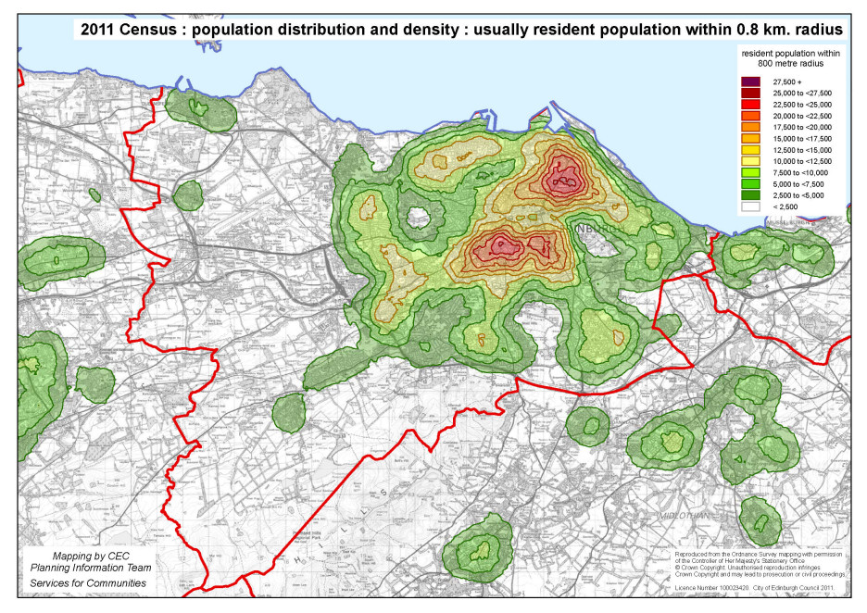 Map 1 (a) 2011 resident population within 0.8km. radius (approx ½ mile) : Edinburgh

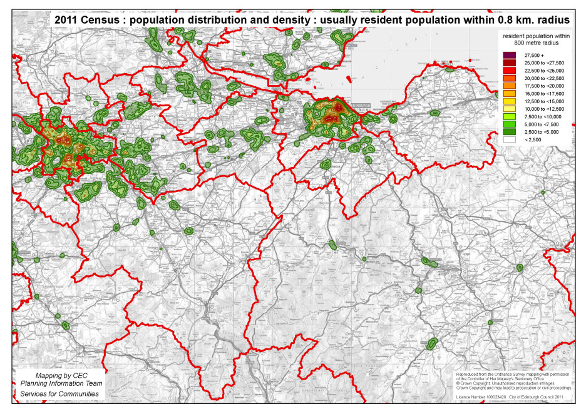 Map 1 (b) 2011 resident population within 0.8km. radius (approx ½ mile) : S.E. Scotland

*Alternative radial catchments (1.6 km. and 3.2 km.)*

1. Partly by way of sensitivity testing, maps 2 (a)/(b) and 3 (a)/(b) show population counts within wider circular catchments of 1,600 metres and 3,200 metres radius respectively, for Edinburgh and the wider area of central / south east Scotland. 1,600 metres is about 1 mile and 3,200 metres equates to 2 miles. In very broad terms these could be interpreted as the sort of distance covered by a short bus journey and a longer bus journey.
2. It can be seen that the effect of adopting a wider threshold distance is to progressively smooth out the peaks and troughs in the densities. At 1,600 metres the area of greatest population concentration takes the form of a dumb-bell shape extending from Leith Walk to Fountainbridge, but with a slight dip still apparent in the city centre core. However, at 3,200 metres the two peaks merge to give a single cone focussed on the city centre. Although the *total* catchment population will clearly be greater as the circle of interest is extended, *peak densities* per sq.km. will be substantially *reduced* because areas of very high density are counterbalanced by surrounding lower densities and areas of open space or commercial uses. Conversely, neighbourhoods with localised low population densities will be bolstered by surrounding areas with higher concentrations.
3. It is interesting to note that Edinburgh remains the most densely populated settlement in Scotland even when taking this broader spatial perspective. For example there are some 208,000 people who live within 2 miles of Edinburgh city centre, compared with 172,000 within 2 miles of Glasgow city centre.
4. At the broader scale, map 3 (b) shows that the two largest cities become increasingly dominant within their hinterlands in terms of the catchment populations available to them – a factor which is significant when considering the location of services. In south east Scotland outwith Edinburgh only two settlements have a residential population exceeding 50,000 within 2 miles : Dunfermline (59,000) and Livingston (58,000).
5. It should be emphasised that the focus here is on population densities and catchment populations at the relatively *local* scale (up to 2 miles). If the radial threshold were to be extended from 2 miles to 10 miles, then the population within the ambit of Glasgow city centre will clearly exceed that surrounding Edinburgh. It also needs to be acknowledged that straight-line distances are a simplified way of looking at accessibility, and that in practice the quality of transport networks (as well as barriers to movement) will also exert a strong influence. Nevertheless, these results are informative as a general framework for looking at the distribution and density of population within Edinburgh and beyond.

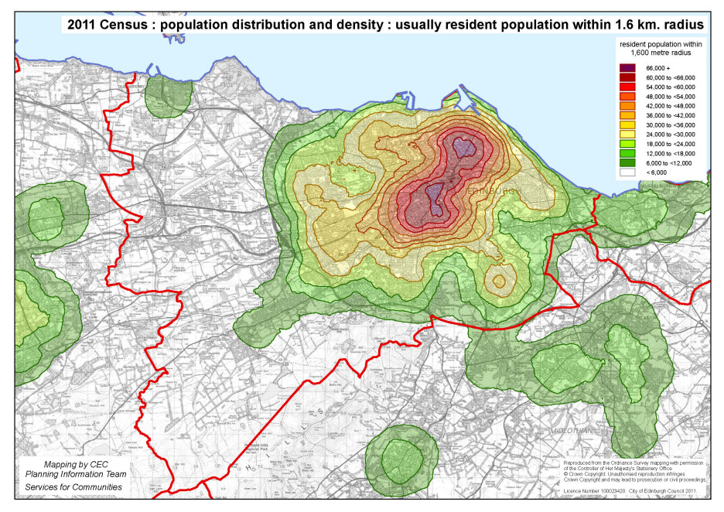 Map 2 (a) 2011 resident population within 1.6km. radius (approx 1 mile) : Edinburgh

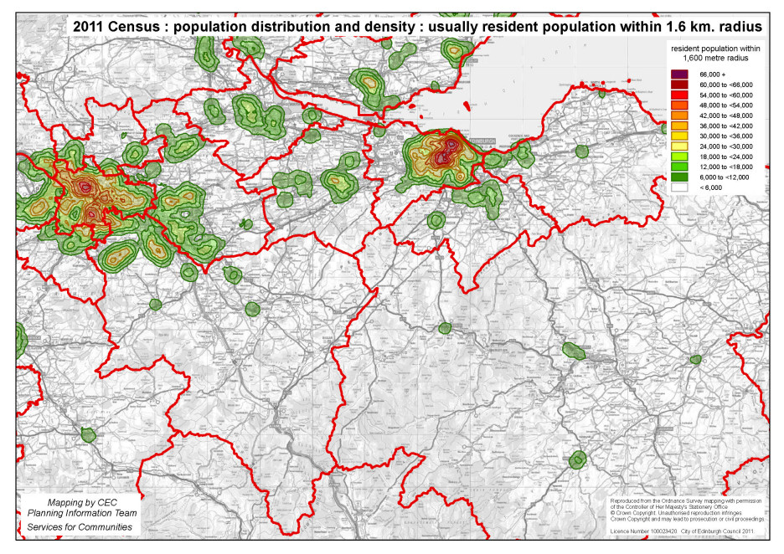 Map 2 (b) 2011 resident population within 1.6km. radius (approx 1 mile) : S.E. Scotland

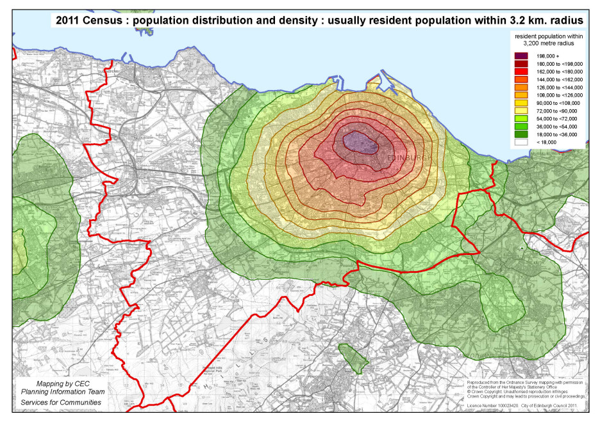 Map 3 (a) 2011 resident population within 3.2km. radius (approx 2 miles) : Edinburgh

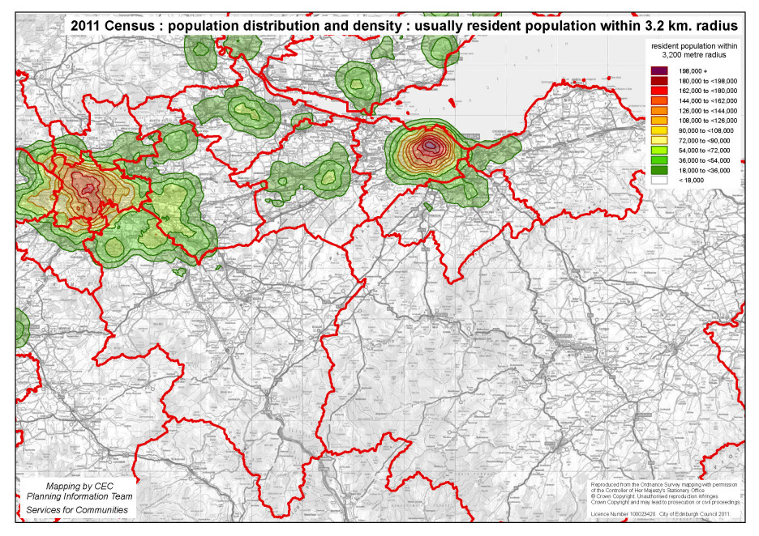 Map 3 (b) 2011 resident population within 3.2km. radius (approx 2 miles) : S.E. Scotland

*Changing population distribution within Edinburgh since 1971*

1. Maps 4(a) to 4(d) show the distribution and density of population over an 800 metre radius for previous censuses – 1971, 1981, 1991 and 2001. These show that the basic radial pattern described earlier has persisted over time, but there have been changes in the actual levels of concentration, especially noticeable in some of the peaks. For example many residential areas in the outer suburban ring had higher densities in 1971 than they do at present – especially the post-war public sector housing estates.
2. Also in 1971 the high density tenemental areas such as Leith Walk / Easter Road and Fountainbridge / Dalry were home to very high concentrations of population similar to the levels recorded in 2011, although in the intervening period between 1971 and 2011 there was a significant loss of population in these areas. The recent recovery in population will almost certainly be due to a combination of factors including new house building on vacant or former commercial sites, and regeneration or modernisation of older properties. It is also possible that older properties are being occupied more intensively, but this will only become clear as more census data is published at the local level.
3. The changes over time are illustrated more starkly in maps 5(a) to 5(c), which simply ‘subtract’ the historic maps from the current (2011) map to show the increase or decrease in the number of people living within an 800 metre radius over the relevant time period. Map 5(a) looks at changes over the last decade, 2001-2011; map 5(b) looks at changes over the last 30 years (1981-2011); and map 5(c) examines changes over the last 40 years (since 1971).
4. Map 5(a) emphasises the very substantial growth in population which has occurred in the Leith Walk area over the last decade, with up to 5,000 additional residents living within 800 metres *(p/800m-rad*). This represents a growth rate in the order of 25-30%, which could be highly significant in terms of the local demand for services and infrastructure investment. The population has in fact grown throughout the broad central swathe of the city extending from Leith and Newhaven, through Broughton and Leith Walk, the South Side, Tollcross and Fountainbridge to Dalry, Gorgie and Slateford. This largely coincides with the belt of high density tenemental property mixed with commercial uses, and recent regeneration and infilling activity is once again likely to have played a major role in bringing about these changes. The other significant area of growth has been in the Granton / Crewe Toll area, which has seen substantial new housing development over the last decade.
5. As might be expected, the shifts in population have been even more dramatic since 1981 (map 5(b)), with the population within 800 metres growing by as much as 9,000 people both in Leith and the South Side. In contrast, the three largest areas of public sector housing on the outskirts of the city have all seen substantial reductions in population (Muirhouse / Pilton, Craigmillar / Niddrie, and Wester Hailes). The biggest losses have been in Craigmillar and Niddrie, but as map 5(a) shows, there are now signs that recent regeneration efforts have started to reverse this trend over the last decade.
6. The pattern of change since 1971 is more complex (see map 5(c)). The big losses of population from Muirhouse / Pilton and Craigmillar / Niddrie are still apparent, but Wester Hailes now appears as the area of greatest population increase, as this was largely developed in the mid to late 1970s. Some larger private housing developments also show up on the map as areas of population growth, for example at East Craigs, Baberton, Buckstone and Echline (South Queensferry). In the inner areas, population in the South Side shows the strongest recovery since 1971, with Leith also witnessing a significant uplift. However, some central areas have seen little change or even a small reduction in local population – notably in the Greenside / Abbeyhill area. The redevelopment of housing areas to create the St. James Shopping Centre in the early 1970s is likely to have been one factor contributing to this.

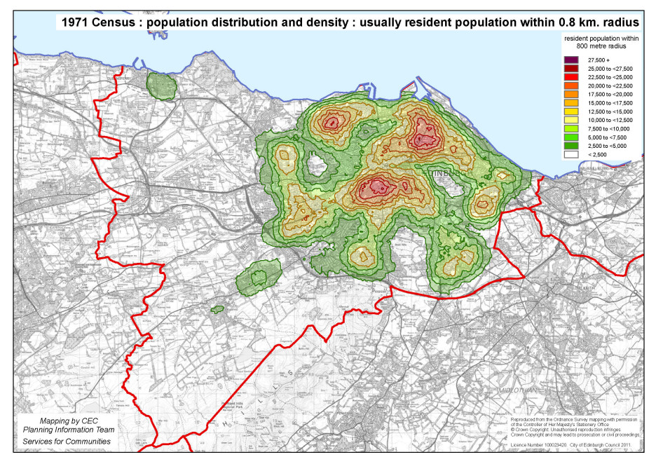 Map 4 (a) **1971** resident population within 0.8km. radius (approx ½ mile)

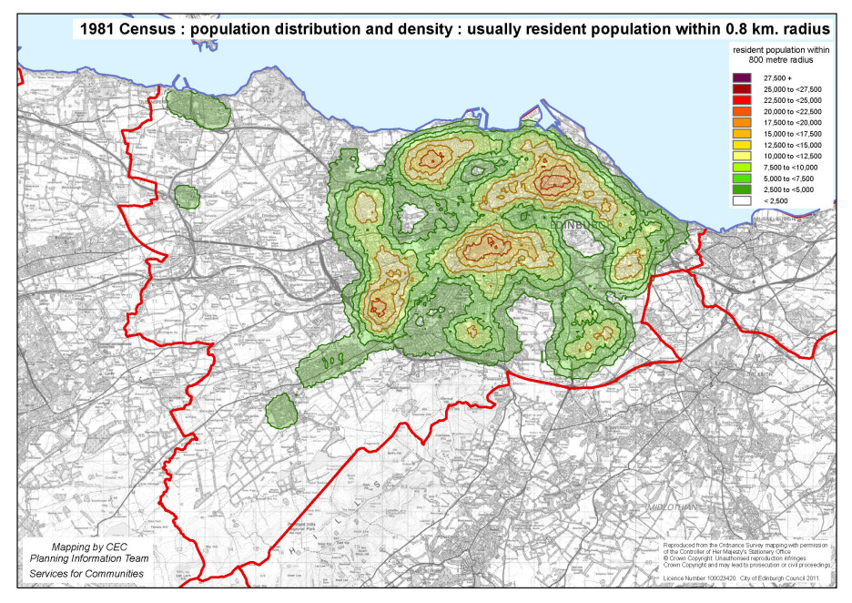 Map 4 (b) **1981** resident population within 0.8km. radius (approx ½ mile)

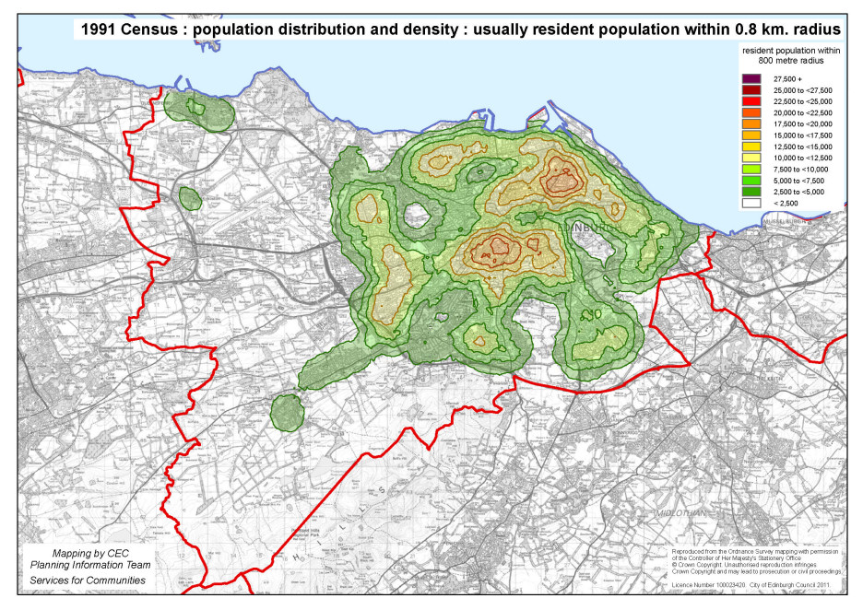 Map 4 (c) **1991** resident population within 0.8km. radius (approx ½ mile)

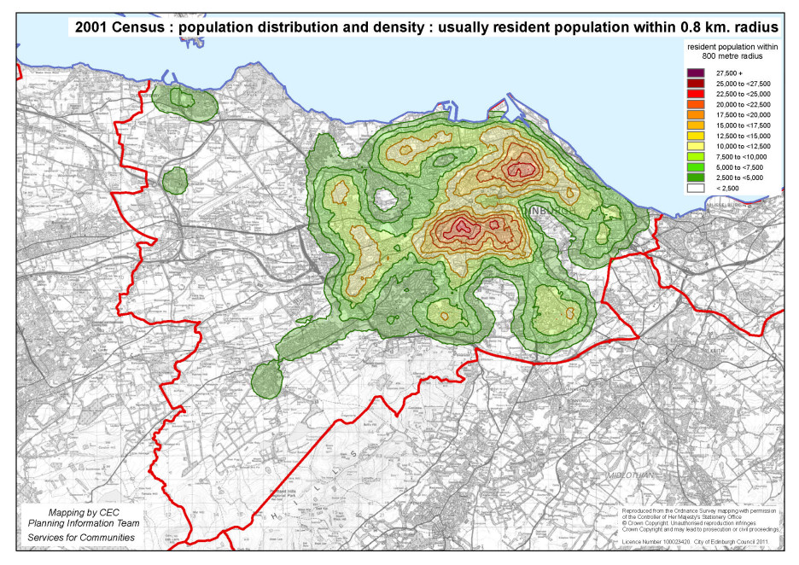 Map 4 (d) **2001** resident population within 0.8km. radius (approx ½ mile

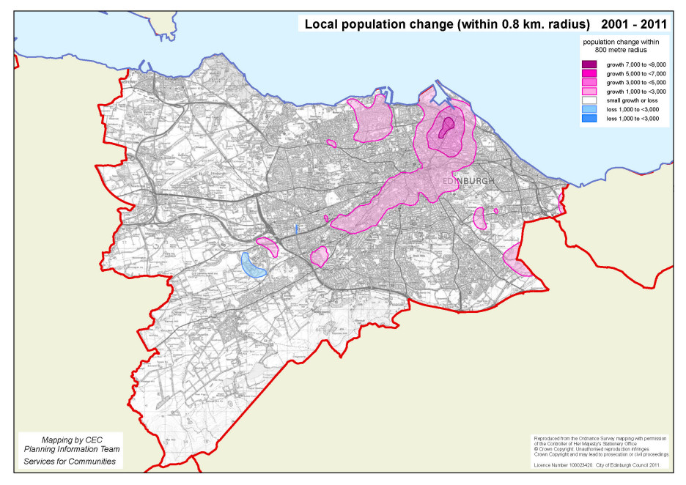 Map 5 (a) Local population change ( within 0.8 km radius) **2001 - 2011**

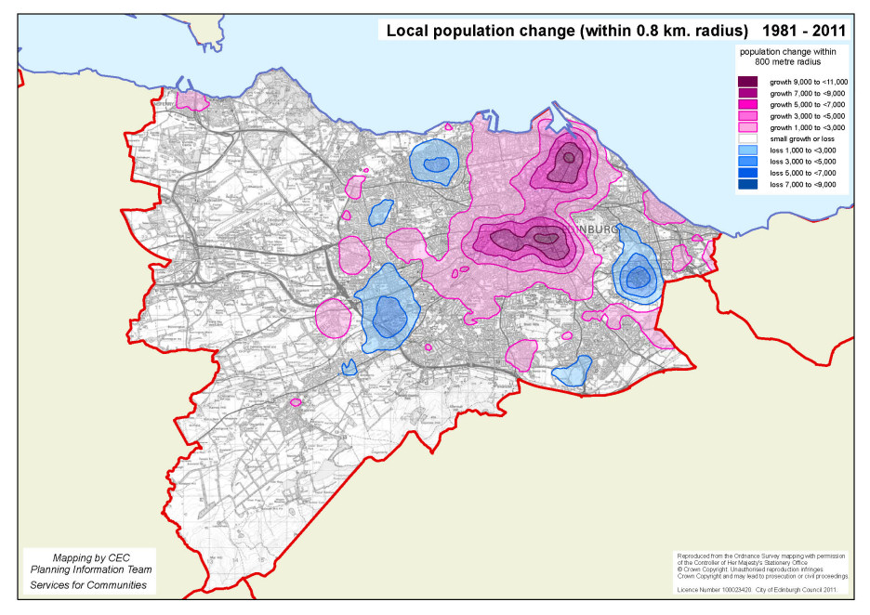 Map 5 (b) Local population change ( within 0.8 km radius) **1981 - 2011**

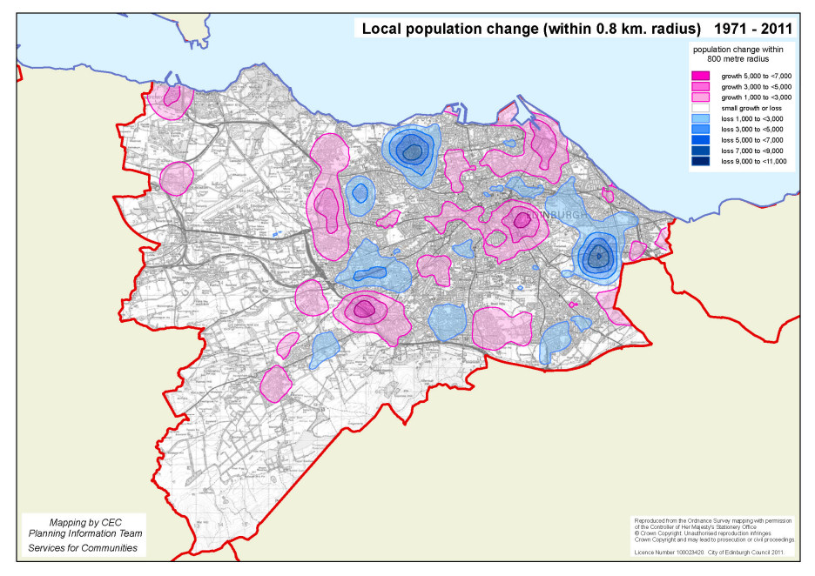 Map 5 (c) Local population change ( within 0.8 km radius) **1971 - 2011**

1. An interesting way of summarising the changing population distribution over the last five censuses is to look at the total number of people in different distance bands from the city centre, as shown in Table 2 and Graphs 1 & 2 below. (For convenience, these assume that the centre of the city is the middle of Princes Street, at the foot of the Mound. Note that the analysis purely relates to the population resident within the City of Edinburgh, and so does not pick up the growing populations in the surrounding local authority areas within the Lothians).

|  |  |  |  |  |  |
| --- | --- | --- | --- | --- | --- |
| Table 2 : Cumulative resident population by distance from Edinburgh City Centre 1971 – 2011 Censuses | | | | | |
|  |  |  |  |  |  |
|  | 1971 | 1981 | 1991 | 2001 | 2011 |
| Distance band |  |  |  |  |  |
| 0 to 1 km. | 20,232 | 12,327 | 14,189 | 17,755 | 19,790 |
| 0 to 2 km. | 95,276 | 69,757 | 74,661 | 89,577 | 99,792 |
| 0 to 3 km. | 181,715 | 135,736 | 146,124 | 169,044 | 185,095 |
| 0 to 4 km. | 257,147 | 201,815 | 211,277 | 237,136 | 260,839 |
| 0 to 5 km. | 325,108 | 260,089 | 261,715 | 285,660 | 314,409 |
| 0 to 6 km. | 402,137 | 328,823 | 328,457 | 355,418 | 384,491 |
| 0 to 7 km. | 441,211 | 380,213 | 374,946 | 402,013 | 430,250 |
| 0 to 8 km. | 451,516 | 396,069 | 389,619 | 417,724 | 446,497 |
| 0 to 12 km. | 463,625 | 408,011 | 401,656 | 431,058 | 459,121 |
| 0 to 16 km. | 475,680 | 424,962 | 419,222 | 448,624 | 476,626 |

1. Table 2 and Graph 1 show that the population in the heart of the city centre (0 to 1 km. from the centre) has almost recovered to its 1971 level, after suffering a 39% decline in the 1970s. In the inner suburbs, between 1 km. and 4 km., the population now *exceeds* its 1971 level, having grown by 16% since 1981.
2. Between 4 km. and 6 km. from the city centre the population is now 15% lower than in 1971. Looking at the figures more closely, there has been a slow recovery since the mid 1990s following a steep decline in the 1970s and 1980s. This band encompasses areas such as Muirhouse, Silverknowes, Clermiston, Stenhouse, Oxgangs, Liberton, Moredun, Craigmillar and Portobello.
3. Towards the outer edges of the main built-up area (between 6 km. and 8 km. from the city centre), the population has grown by 26% since 1971, reflecting the development of new housing areas on the edge of the city. There has been little change in population in the band between 8km. and 12 km., which largely coincides with the green belt in the west of Edinburgh. Finally, beyond 12km. the total population is small, being mostly accounted for by the detached settlement of South Queensferry. The population here grew rapidly in the 1970s, but since 1991 it has remained largely stable.
4. Overall, despite the development of some new residential areas on the edge of the city, Edinburgh has remained a compact city. In fact some 55% of the population now live within 4 km. of the city centre – a higher proportion than in 1971 (54%), and substantially higher than in 1981 (48%). (See Graph 2) This perhaps reflects the success of many policies and initiatives over the last 30 years which have sought to encourage sustainable urban living and bring people back to the heart of the city. However, as indicated already, the wider regional context also needs to be acknowledged, as substantial population growth has also occurred outwith the boundaries of the city, linked inextricably to Edinburgh’s economic growth.

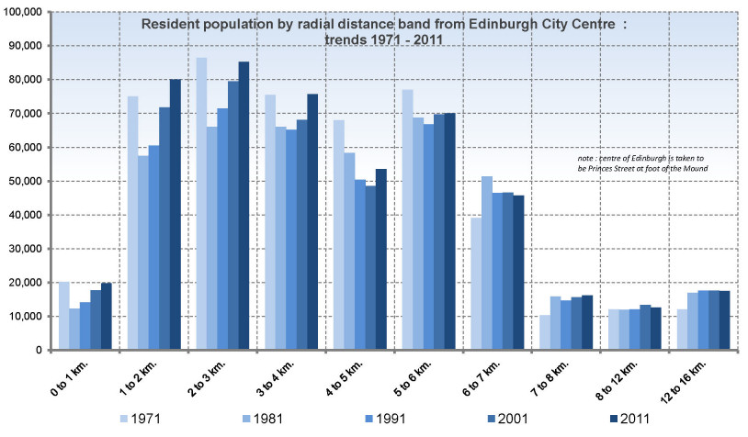 Graph 1 : Population by radial distance around Edinburgh City Centre, 1971 - 2011

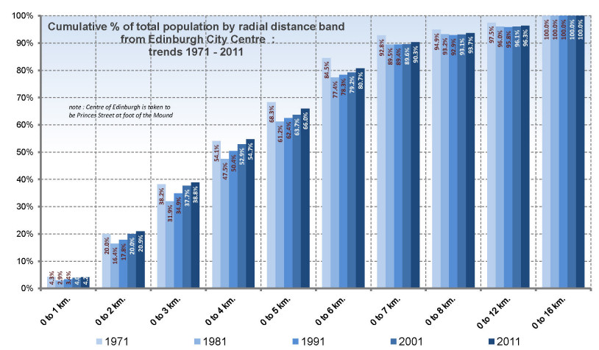 Graph 2 : Cumulative % of population by distance from Edinburgh City Centre, 1971 - 2011

*Technical notes :*

1. Analysis of population change over time will be affected by definitional changes between successive censuses – in particular who is counted at which address. It is thought that these differences are unlikely to affect the broader picture as portrayed in this analysis, although they do mean that a margin of error needs to be allowed for when looking at detailed local figures. For convenience, the key definitions for censuses between 1971 and 2001 are set out in Appendix 2.
2. In deriving population change by subtracting earlier population distributions from that in 2011, it should be borne in mind that the 2011 dataset included output area populations for the whole of Scotland whereas previous datasets were limited purely to Edinburgh. Close to the city boundaries (i.e. within the 800 metre radial distance) this gives the false impression of a population increase. However there are very few places where significant settlements outside the city lie this close to the city boundary, the main instances being Danderhall and the western fringes of Musselburgh.

**Appendix 1**

Comparative local  
population densities  
in selected cities across the UK

(2011 Census)

All the following maps are to the same scale, and show the number of residents who live within an 800 metre radius (approx. half a mile) of any point on the map. The areas of highest population density are shaded red and purple.

Population density key for UK city maps

|  |  |  |  |  |  |
| --- | --- | --- | --- | --- | --- |
| Comparative peak population densities for selected cities | | | | | |
|  |  |  |  |  |  |
| map ref. | city / metropolitan region |  | peak population within 800m radius |  | locality with highest population density |
|  |  |  |  |  |  |
|  | SCOTLAND |  |  |  |  |
| 1 | Edinburgh |  | 25,950 |  | Leith Walk |
| 2 | Glasgow |  | 22,000 |  | Partick |
| 3 | Aberdeen |  | 18,100 |  | Rosemount |
| 4 | Dundee |  | 15,300 |  | Dens Road |
|  | ENGLAND & WALES |  |  |  |  |
| 5 | Bournemouth |  | 25,050 |  | St. Clement’s Road |
| 6 | Brighton and Hove |  | 38,350 |  | Aldrington |
| 7 (a) | Bristol |  | 21,750 |  | Cotham |
| 7 (b) | Bath |  | 19,750 |  | George Street |
| 8 | Cambridge |  | 16,500 |  | Mill Road |
| 9 | Cardiff |  | 24,100 |  | Cathays |
| 10 (a) | Derby |  | 18,550 |  | Rose Hill |
| 10 (b) | Nottingham |  | 23,350 |  | Lenton |
| 11 | Hull |  | 17,350 |  | Southcoates |
| 12 | Leicester |  | 25,550 |  | Spinney Hills |
| 13 | London |  | 45,850 |  | Kensington |
| 14 | Manchester |  | 21,000 |  | Hulme |
| 15 | Merseyside |  | 21,250 |  | Wavertree (Liverpool) |
| 16 | Middlesbrough |  | 18,650 |  | Linthorpe Road |
| 17 | Northampton |  | 16,550 |  | Kettering Road |
| 18 | Oxford |  | 13,300 |  | Cowley Road |
| 19 | Plymouth |  | 20,750 |  | Lipson |
| 20 | South Yorkshire |  | 18,850 |  | Walkley (Sheffield) |
| 21 (a) | Southampton |  | 17,200 |  | Shirley |
| 21 (b) | Portsmouth |  | 28,150 |  | Southsea |
| 22 | Southend-on-Sea |  | 24,350 |  | Westborough Road |
| 23 | Swansea |  | 15,000 |  | Walter Road |
| 24 (a) | Tyneside - Newcastle |  | 16,650 |  | Heaton |
| 24 (b) | Tyneside - Gateshead |  | 18,250 |  | Bensham |
| 25 | West Midlands |  | 20,250 |  | Moseley (Birmingham) |
| 26 (a) | West Yorkshire - Leeds |  | 21,150 |  | Burley |
| 26 (b) | West Yorkshire - Bradford |  | 15,900 |  | Manningham |
| 26 (c) | West Yorkshire - Halifax |  | 16,050 |  | Thrum Hall |
|  |  |  |  |  |  |

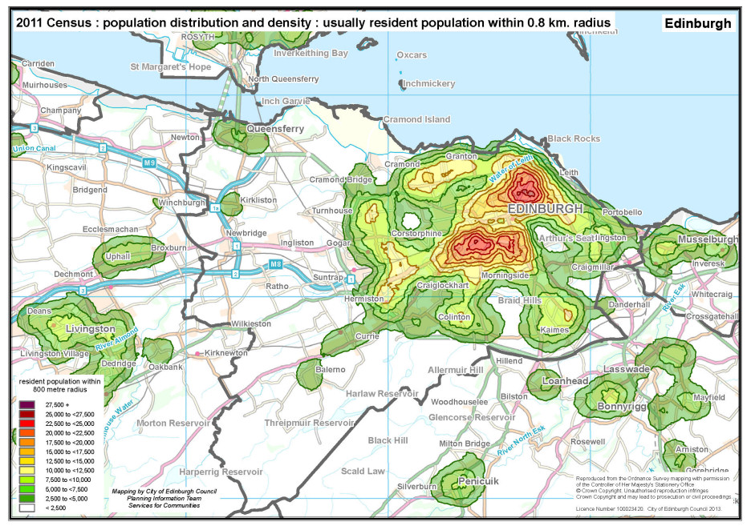 Population resident within an 800 metre radius : (1) Edinburgh

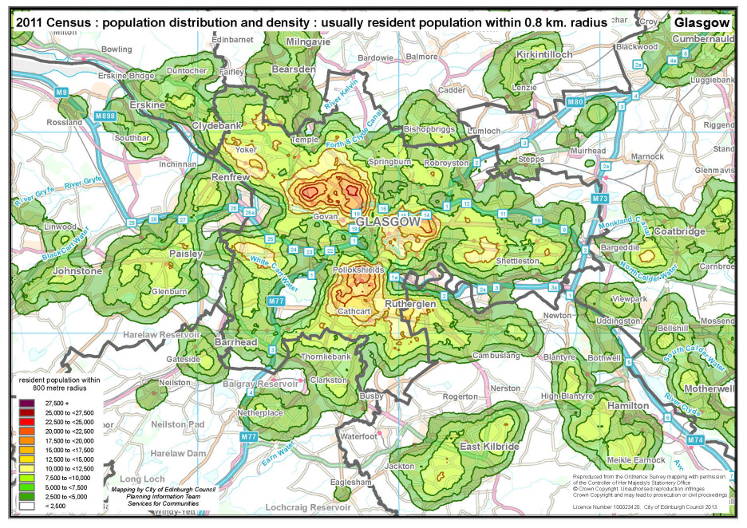 Population resident within an 800 metre radius : (2) Glasgow

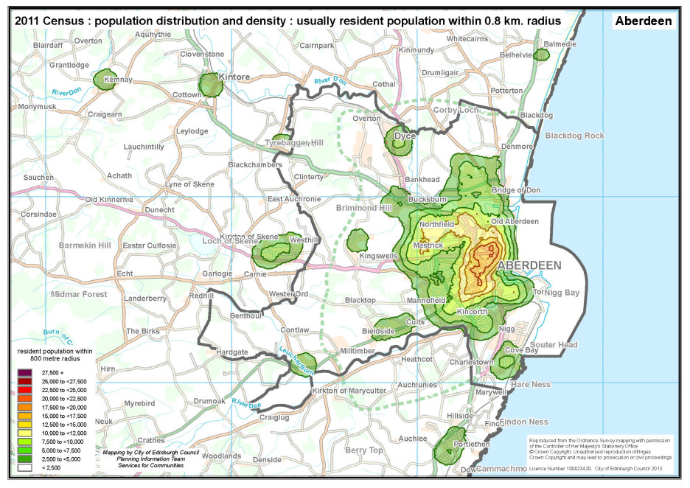 Population resident within an 800 metre radius : (3) Aberdeen

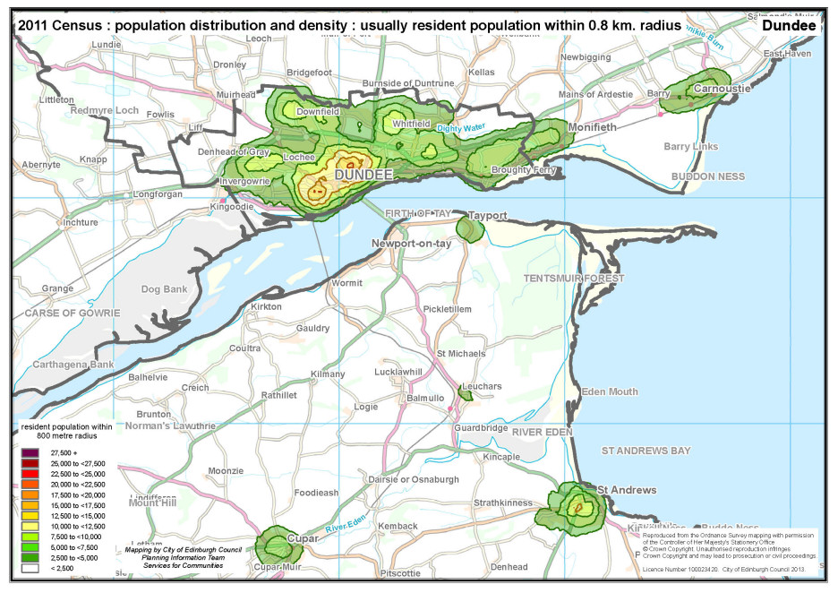 Population resident within an 800 metre radius : (4) Dundee

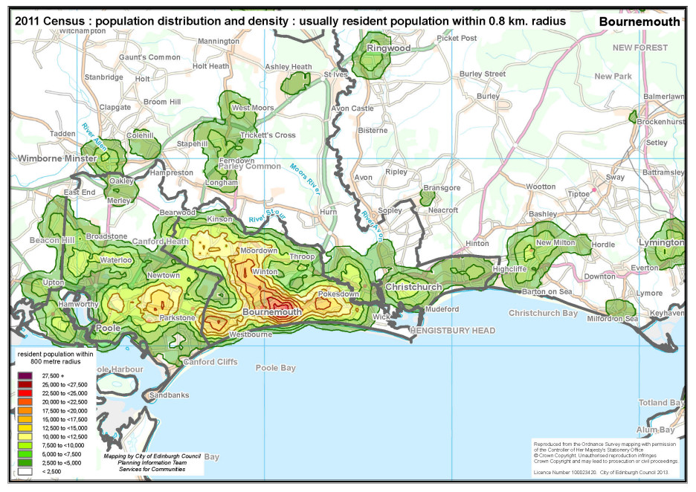 Population resident within an 800 metre radius : (5) Bournemouth

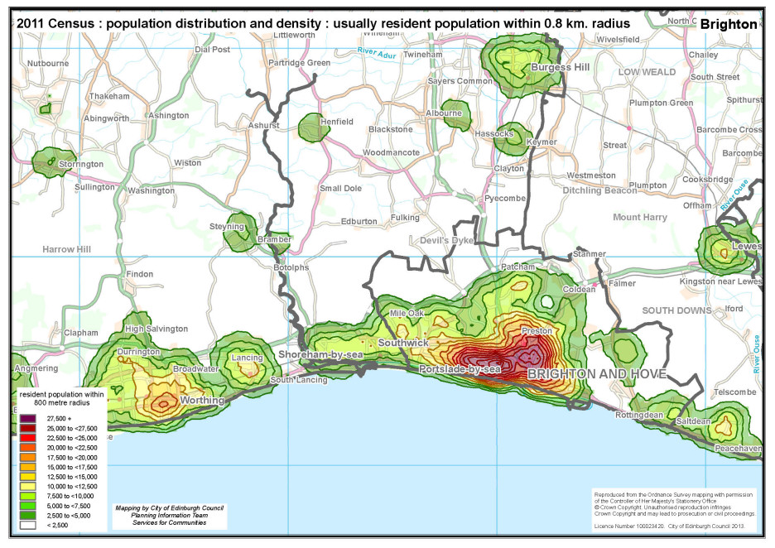 Population resident within an 800 metre radius : (6) Brighton and Hove

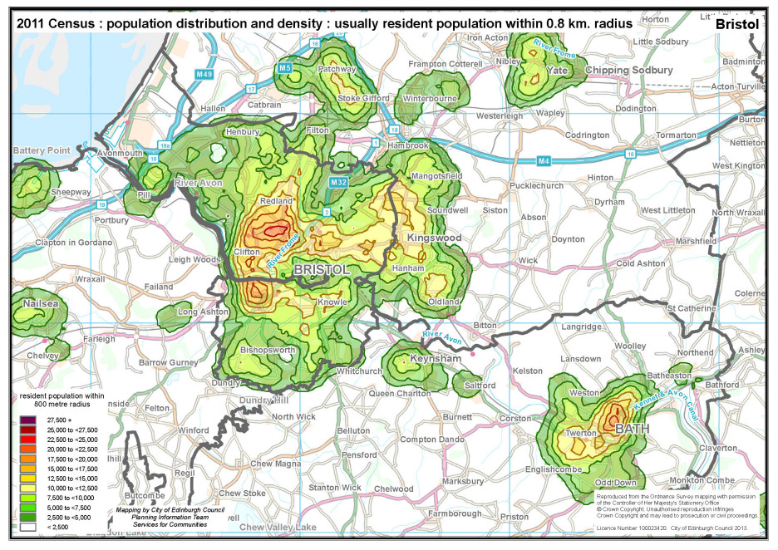 Population resident within an 800 metre radius : (7) Bristol and Bath

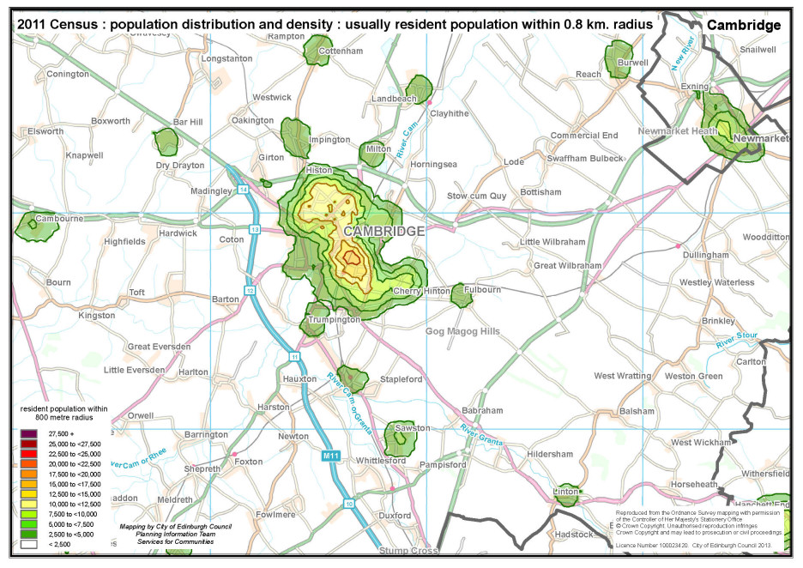 Population resident within an 800 metre radius : (8) Cambridge

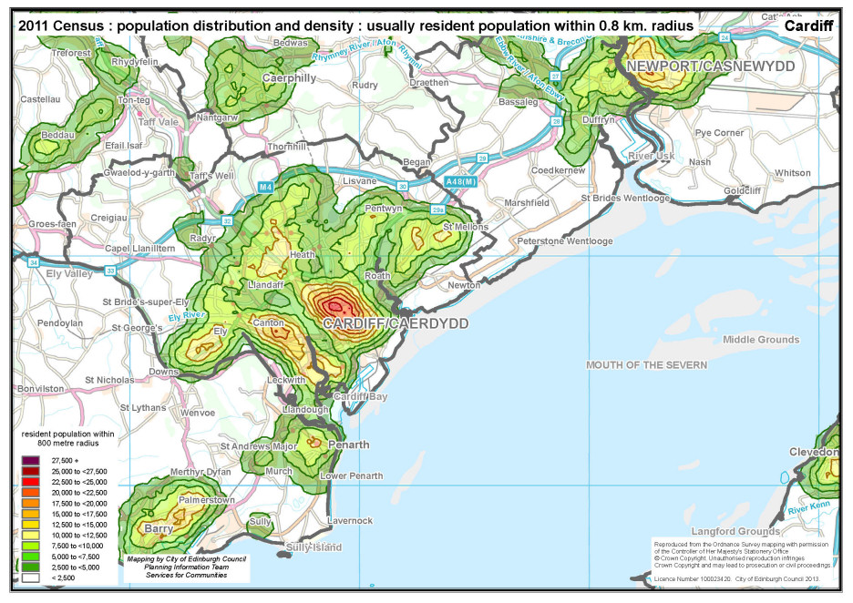 Population resident within an 800 metre radius : (9) Cardiff

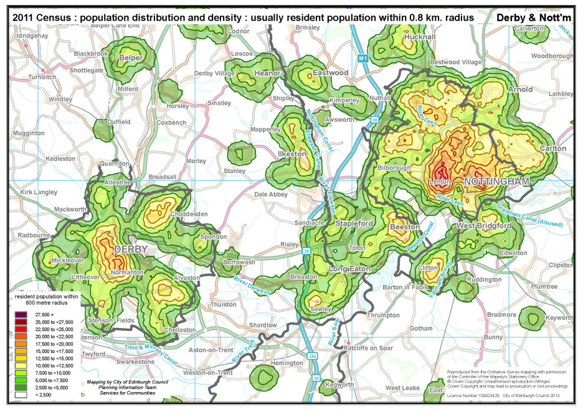 Population resident within an 800 metre radius : (10) Derby and Nottingham

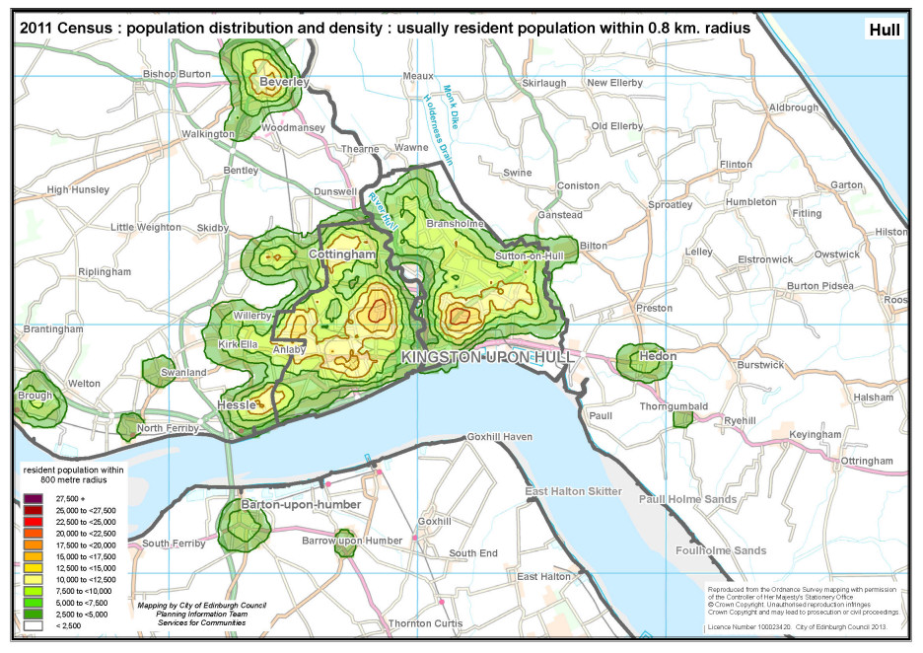 Population resident within an 800 metre radius : (11) Hull

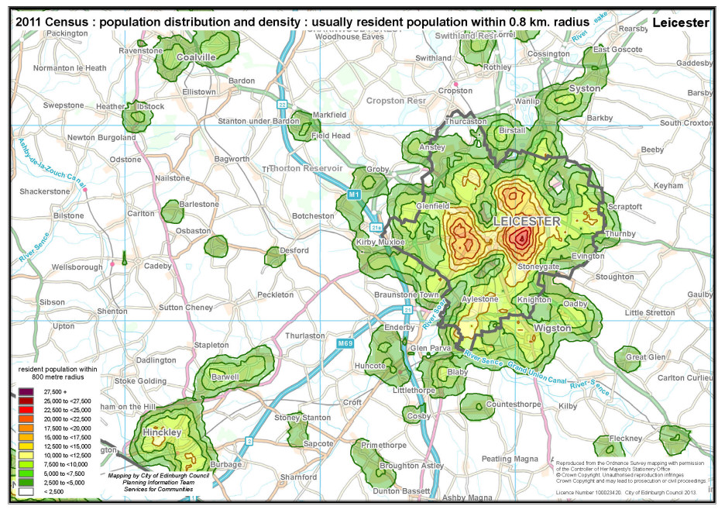 Population resident within an 800 metre radius : (12) Leicester

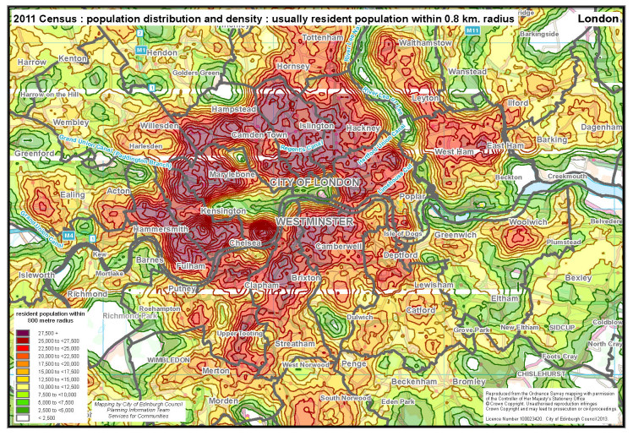 Population resident within an 800 metre radius : (13) London

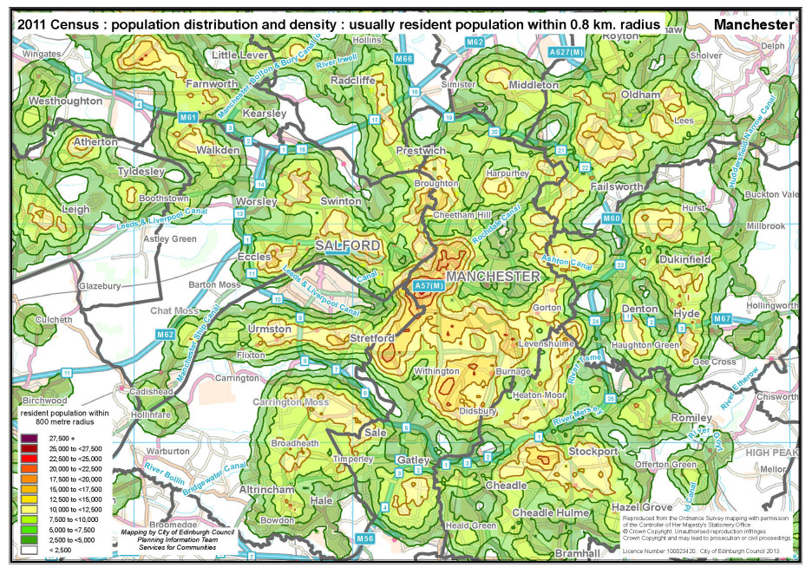 Population resident within an 800 metre radius : (14) Manchester

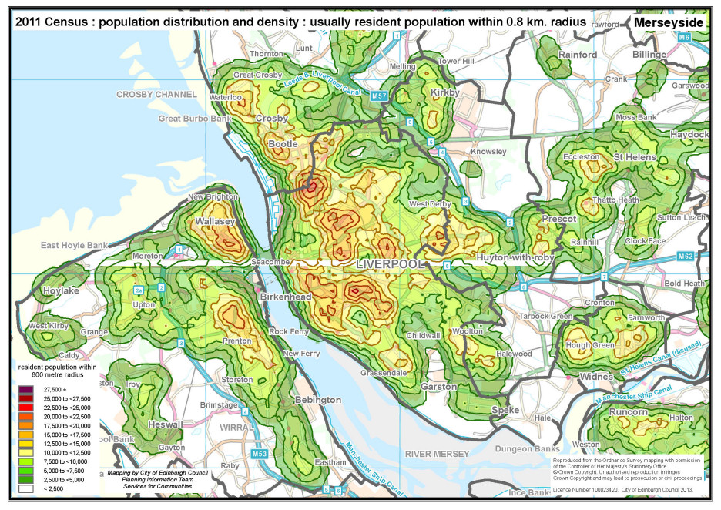 Population resident within an 800 metre radius : (15) Merseyside

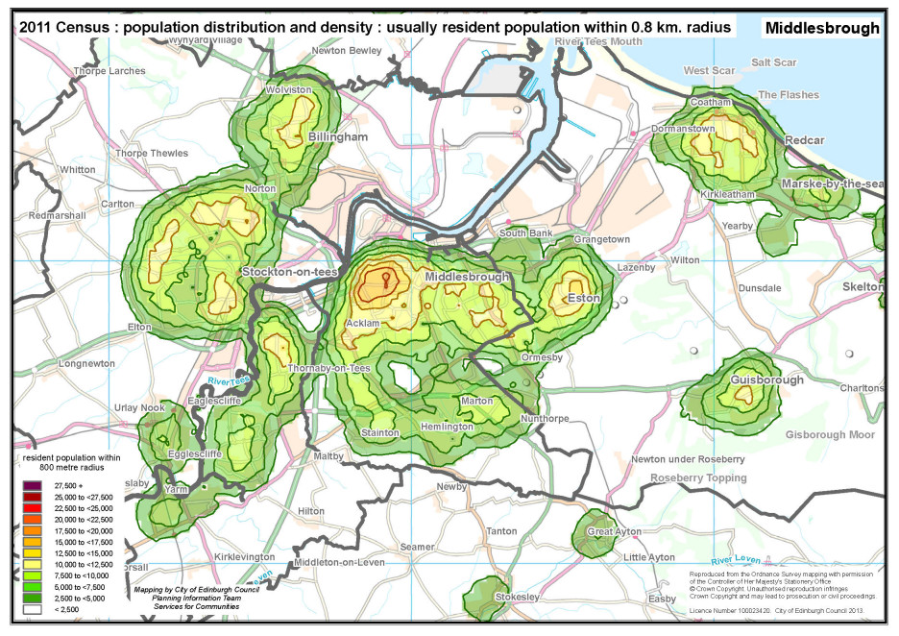 Population resident within an 800 metre radius : (16) Middlesbrough

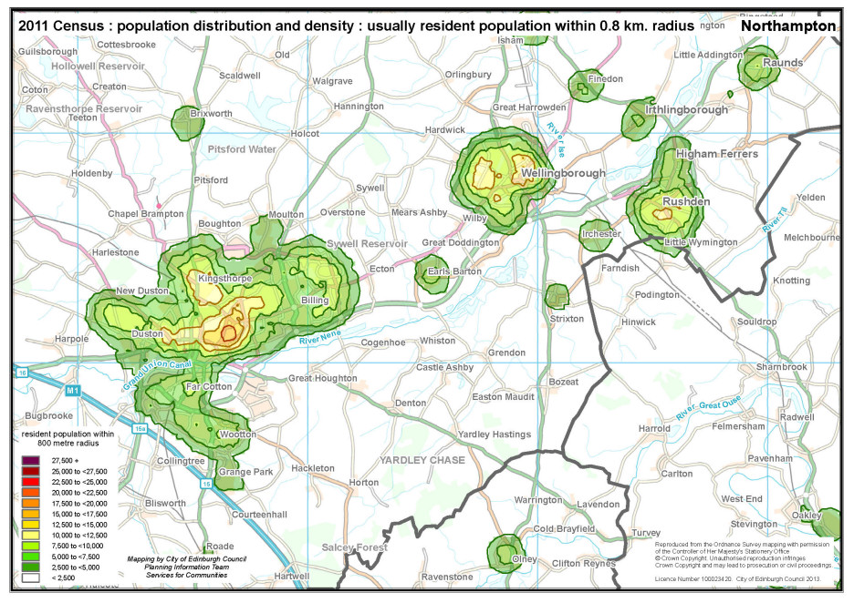 Population resident within an 800 metre radius : (17) Northampton

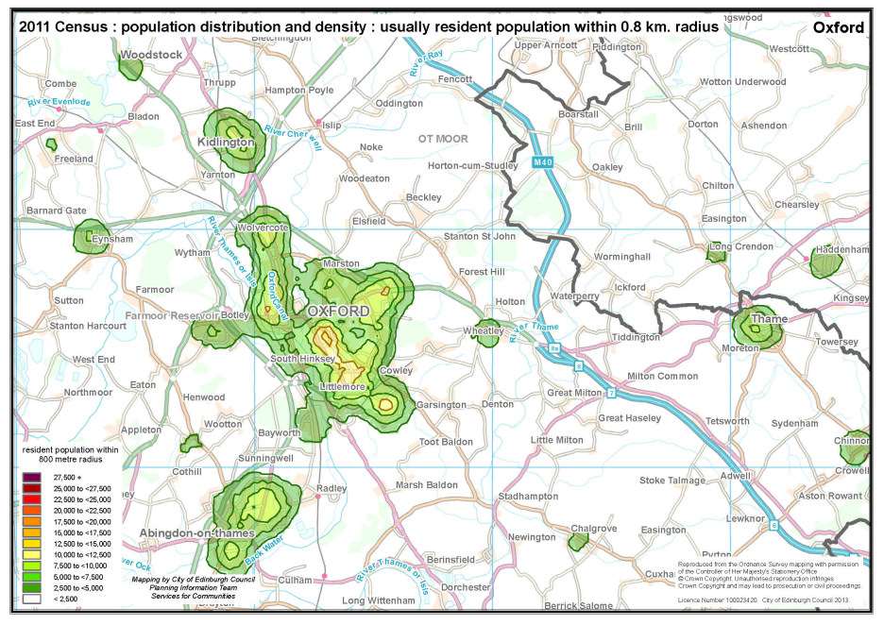 Population resident within an 800 metre radius : (18) Oxford

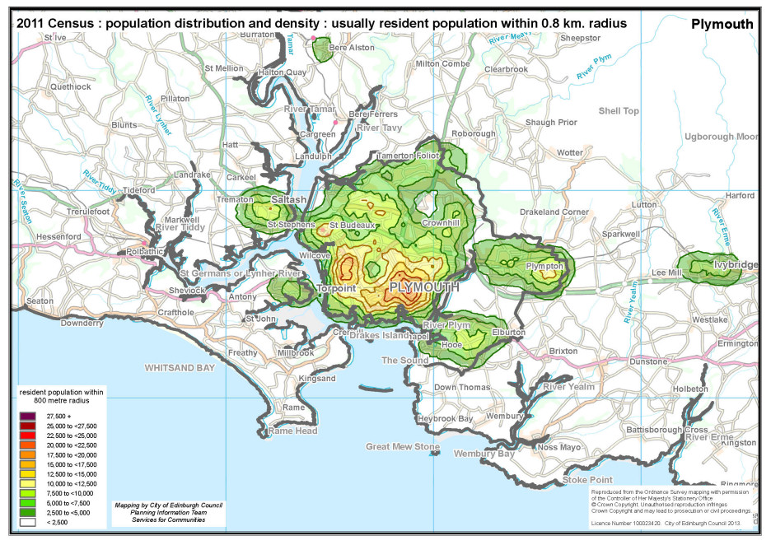 Population resident within an 800 metre radius : (19) Plymouth

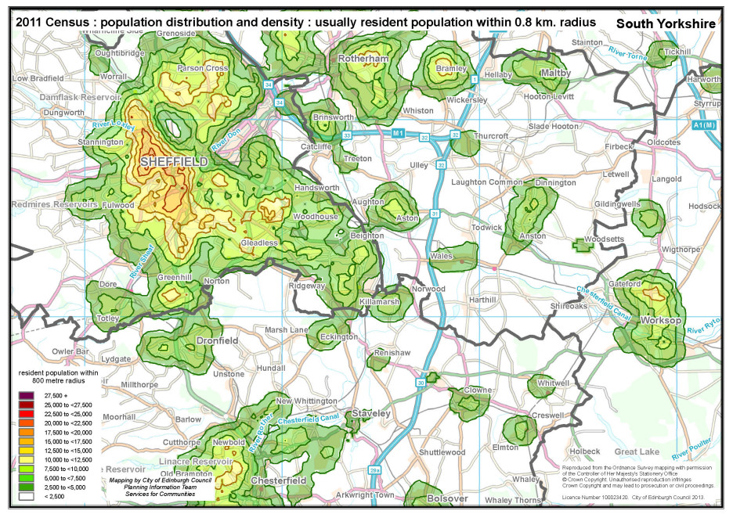 Population resident within an 800 metre radius : (20) South Yorkshire

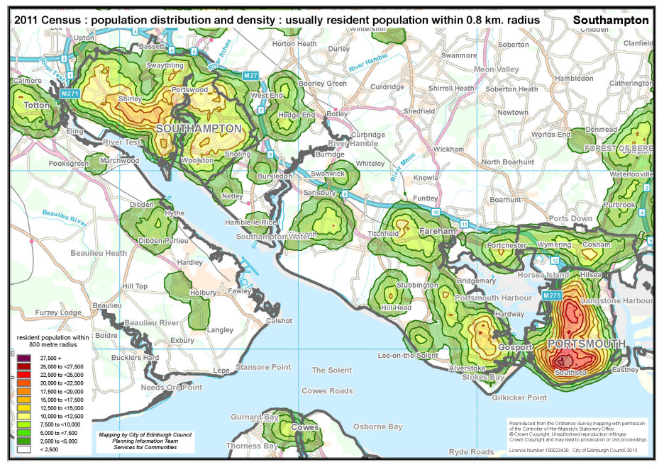 Population resident within an 800 metre radius : (21) Southampton and Portsmouth

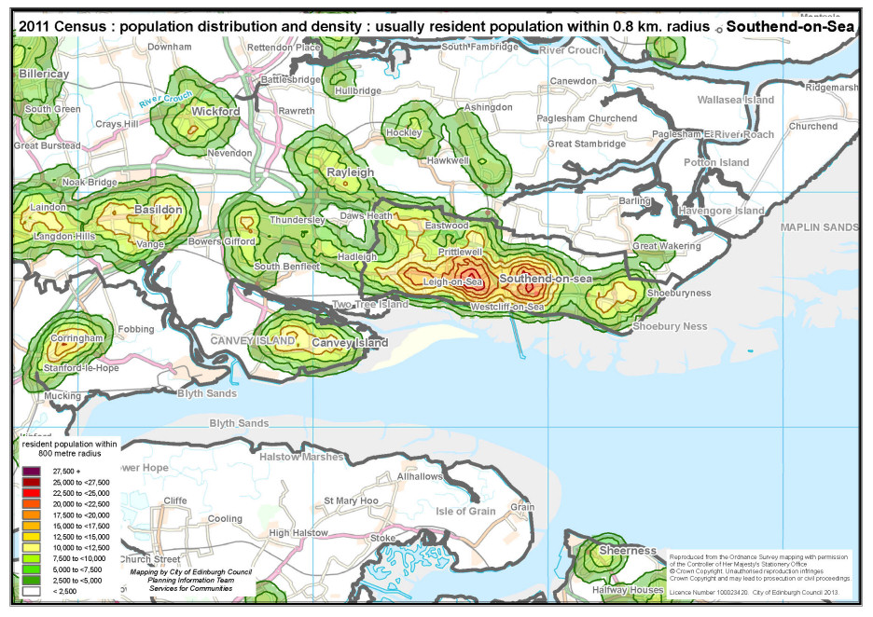 Population resident within an 800 metre radius : (22) Southend-on-Sea

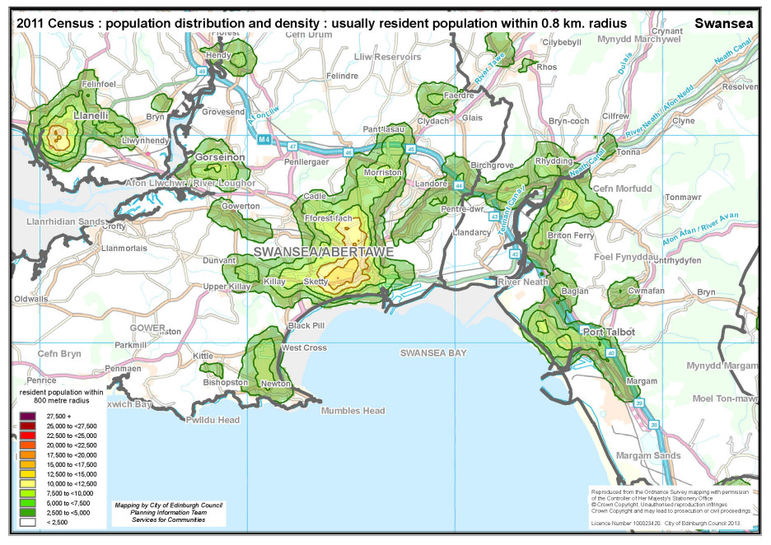 Population resident within an 800 metre radius : (23) Swansea

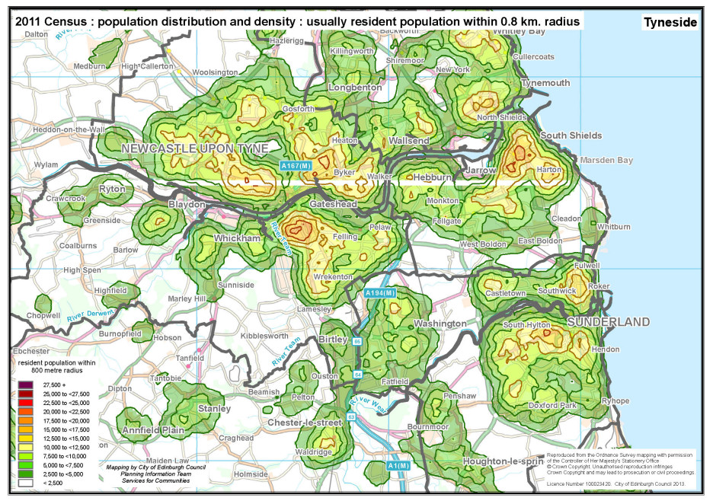 Population resident within an 800 metre radius : (24) Tyneside

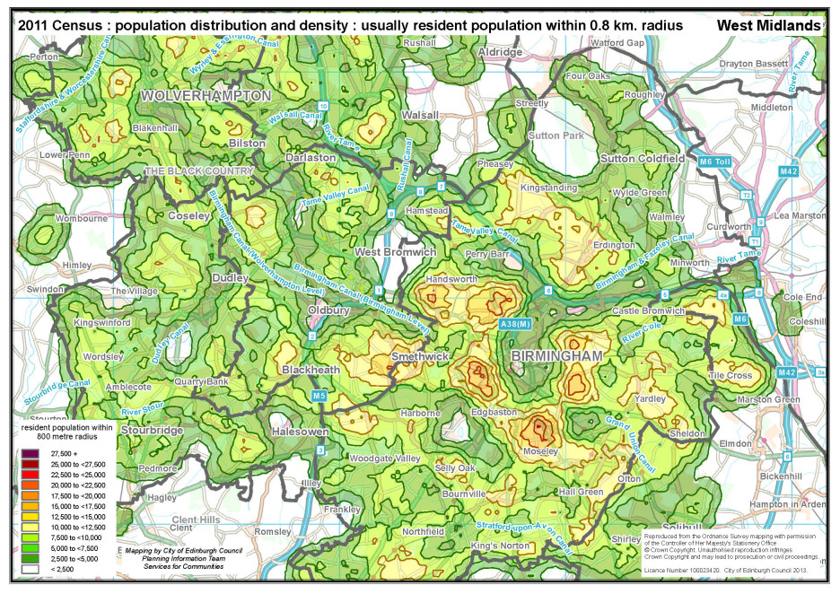 Population resident within an 800 metre radius : (25) West Midlands

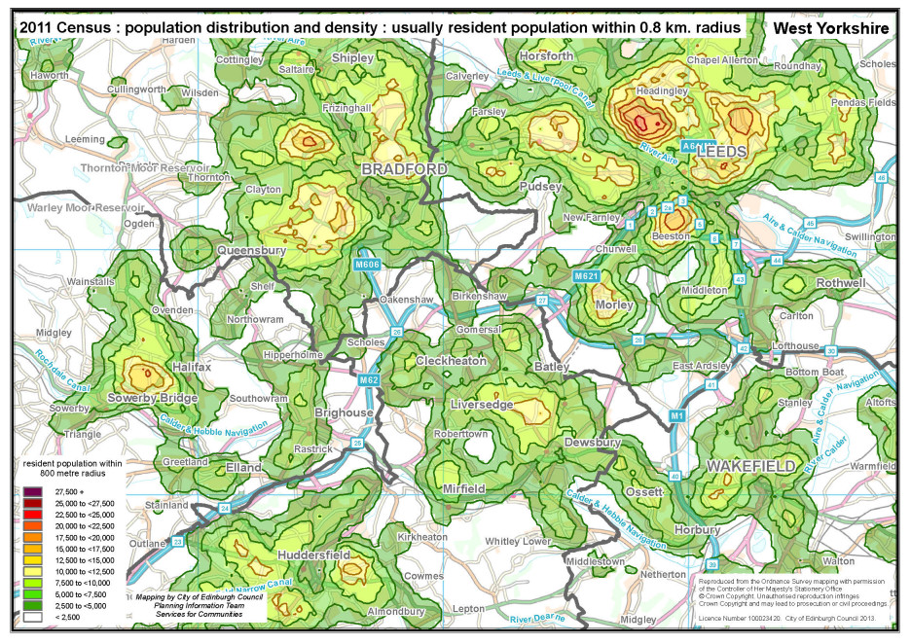 Population resident within an 800 metre radius : (26) West Yorkshire

**Appendix 2**

Key definitions of the population count for censuses between 1971 and 2001

|  |  |  |
| --- | --- | --- |
|  | **‘persons present’** | **‘usually resident’** |
| **1971** | Persons on Census night who spent that night with a household, in a non-private establishment, or elsewhere in the area of enumeration.  Persons working or travelling enumerated at address they joined next morning.  Persons absent recorded seperately but do not feature in population data, either directly or indirectly. | Persons usually living "at this address" and present "at this address" on census night;  *plus* persons returned on forms for the area as usually living "at this address" but present outside Great Britain on census night;  *plus* persons returned on forms  throughout Great Britain as present "at this address" on census night but usually living "elsewhere in GB" at an address within the specified area;  *plus* visitors from outside GB who spent Census night |
| **1981** | All persons recorded as spending Census night in the area regardless of whether this was where they usually lived. | Persons usually living "at this address" and present "at this address" on census night;  *plus* persons returned on forms for the area as usually living "at this address" but present outside Great Britain on census night;  *plus* persons returned on forms  throughout Great Britain as present "at this address" on census night but usually living "elsewhere in GB" at an address within the specified area. |
| **1991** | All persons recorded as spending Census night in the area regardless of whether this was where they usually lived. | All persons recorded as resident in households in an area, even if they were present elsewhere on Census night, plus residents in communal establishments who were present in the establishment on Census night. |
| **2001** | n/a | Someone who spends the majority of  their time residing at that address. It includes:  people who usually live at that address  but who are temporarily away from home  (on holiday, visiting friends or relatives,  or temporarily in a hospital or similar  establishment) on Census Day;  people who work away from home for  part of the time, or who are members of  the Armed Forces;  a baby born before 30th April 2001 even  if it was still in hospital; and  people present on Census Day, even if  temporarily, who have no other usual  address.  Students and schoolchildren in full-time  education studying away from the family home were enumerated as resident at their term-time address.  The usual resident population did not  include people present at an address on Census Day whose usual address was elsewhere; or people away from their home address who had been living, or intended to live, in a special establishment such as a residential home, nursing home or hospital for six months or more. |